The diagram shows the human respiratory (breathing) system.
Name the parts labelled A, B and C.
A _________________________________ ()
B _________________________________ ()
C _________________________________ ()

What do the rings of cartilage do?
___________________________________ ()

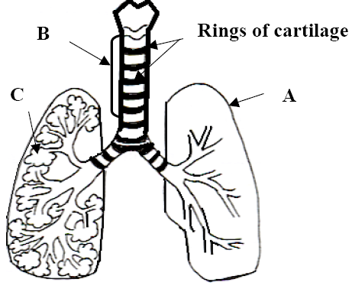

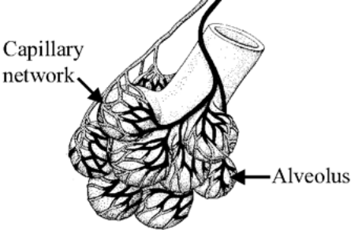
What organ, in our body, contains large numbers of the item shown in the diagram? Give one change that occurs in blood as it moves through the capillary network shown.
Organ ____________________________
Change _________________________

